Add Two Integers
Platform: LeetCode
Language: C
Module 1, Question 3

Problem Link
https://leetcode.com/problems/add-two-integers/description/

Problem Statement
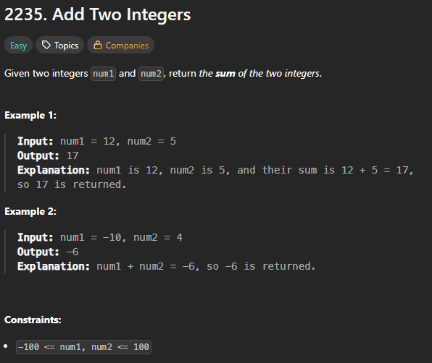

C Code
int sum(int num1, int num2) {
return num1 + num2;
}

Screenshot of Successful Submission



